Blinq Me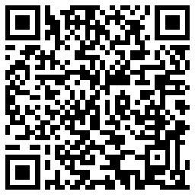
Website
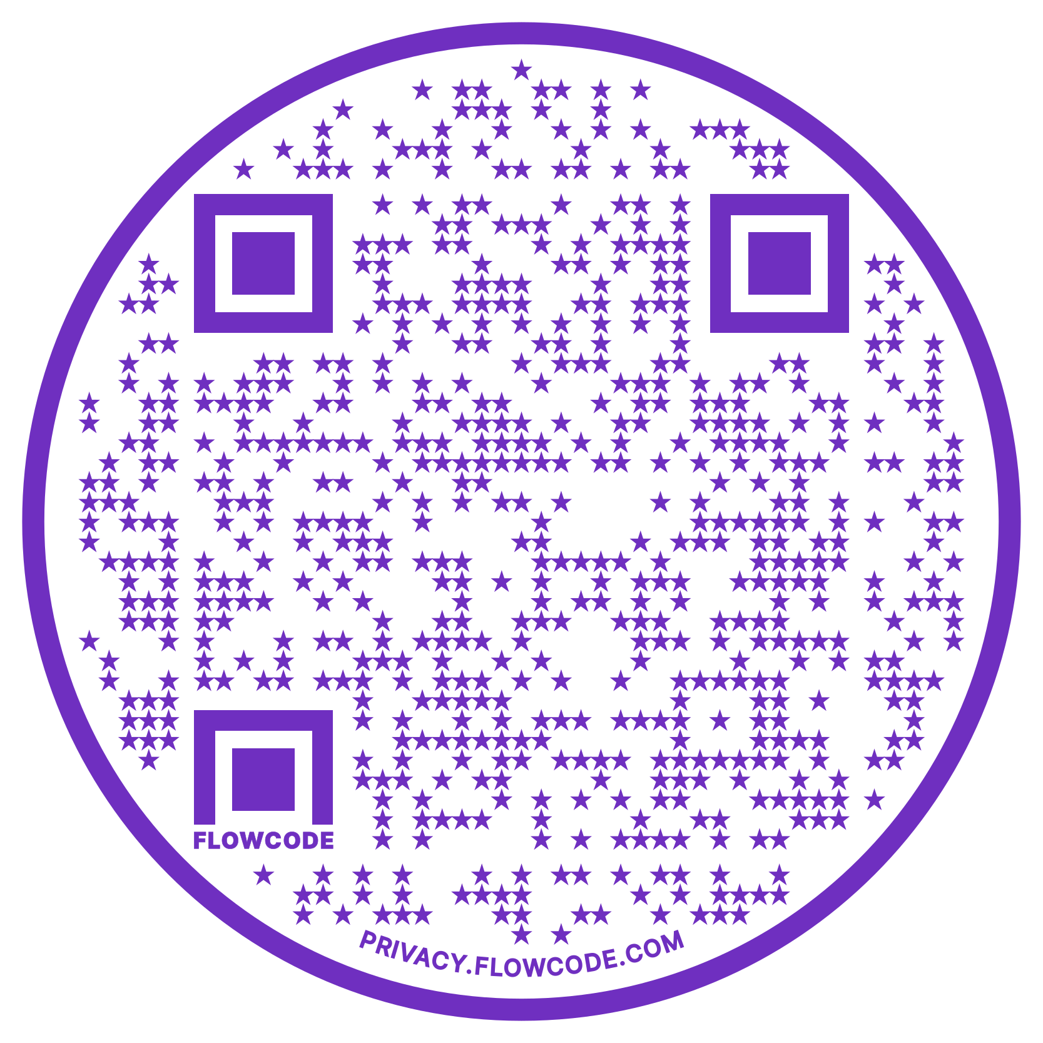

Cellas Ari'ka Hayes, PhD
(601) 506-0052; cahayes3@stanford.edu
https://www.cellashayes.com/

________________________________________________________________________
Noteworthy Programs
Education

Stanford University, Stanford, CA  Degree Type: Postdoctoral Training  Department of Neurology & Neurological Sciences  December 1, 2022- | - Neuroscience Scholars Program Fellow (2022- Present)  - UMMC-GTEC Smith Scholars Program (2020-2022)  - MBL SPINES (2022)  - UM SREB Scholar (2019-2022)  - Neuroscience Scholars Program Associate (2019-2021)
The University of Mississippi, University, MS
Degree Type: Doctor of Philosophy, Ph.D.
Department of BioMolecular Sciences
May 2019-November 8, 2022

The University of Mississippi, University, MS
Degree Type: Bachelor of Arts
First-Author Publications

- Hayes CA, Valcarcel-Ares MN, Ashpole NM (2020) Insulin-like Growth Factor-1 and Ischemic Stroke Outcomes: Evidence from Clinical and Preclinical Interventions. Journal of Cerebral Blood Flow and Metabolism PMID: 33757314
- Hayes CA, (2021) Black Scientists Are Not the Door to Diversity. ACS ChemNeuro
PMID: 34115483
- Hayes CA, Ashmore BG, Vijayasankar A, Marshall JP, Ashpole NM (2021) Insulin-Like Growth Factor-1 Differentially Modulates Glutamate-Induced Toxicity and Stress in Cells of the Neurogliovascular Unit Frontiers in Aging Neuroscience PMID: 34887742
Funding

2019 | Graduate School Counsel Research Grant from the University of Mississippi
2022 | NIH F31 Ruth L. Kirschstein Predoctoral Individual National Research Service Award *First Black Trainee and 3rd in history at UM
2022-2024 | Stanford Propel Postdoctoral Fellowship
Additional Publications, Awards, Presentations, Service, Teaching, Mentorship

5 1st Author Manuscripts Under Review/In Preparation | 300+ Hours of Community Service
2 Coauthor Manuscript Under Review/In Preparation | 27 RCR Hours
25 Honors, Awards, and Features | 4 Hours of Guest Lecturing
9 Noteworthy Features, Videos, and Sci-Comm | 3 Professional Appointments
6 Oral Presentations; 8 Poster Presentations | 13 Mentees
5 Coauthored Presentations | 7 Invited Outreach Talks

